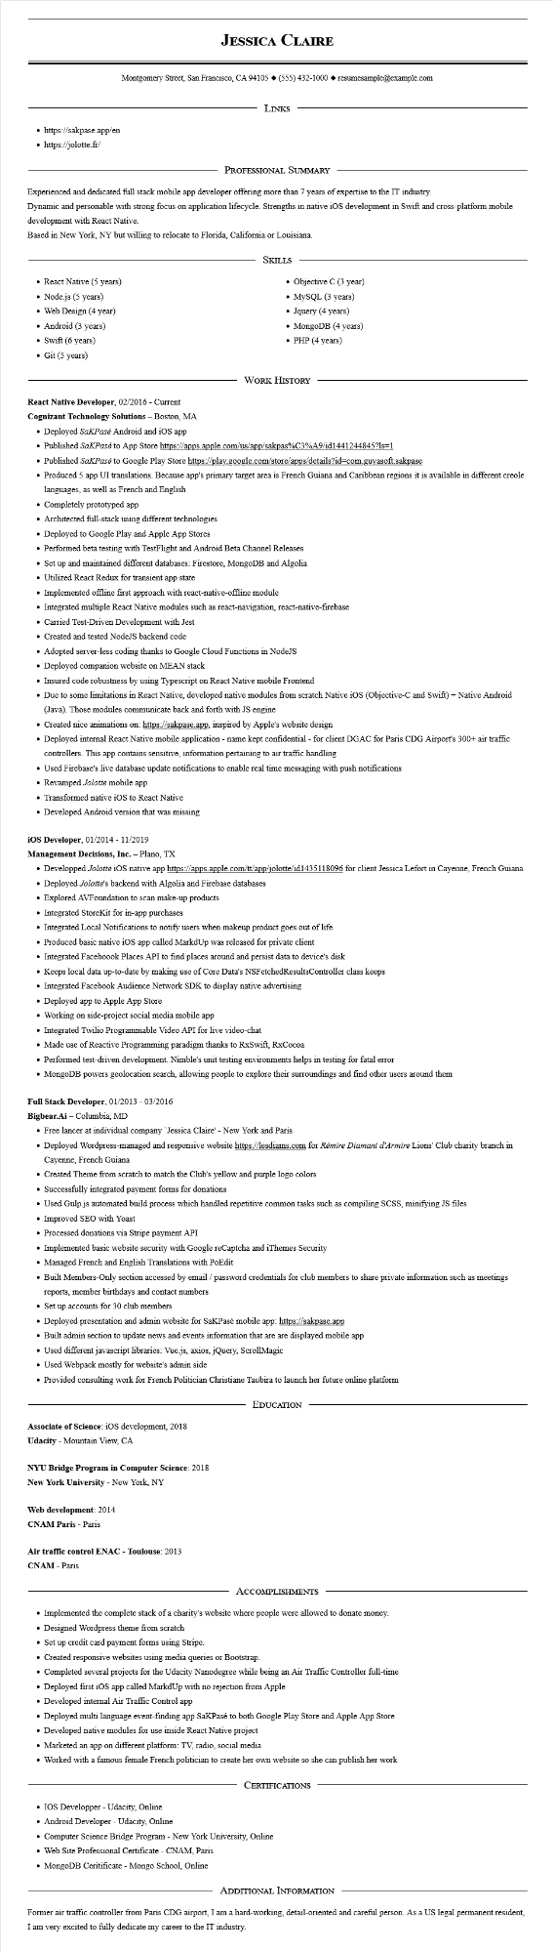
• https://sakpase.app/en
https://jolotte.fr/
JESSICA CLAIRE
Montgomery Street, San Francisco, CA 94105 ♦ (555) 432-1000 resumesample@example.com
LINKS
PROFESSIONAL SUMMARY
Experienced and dedicated full stack mobile app developer offering more than 7 years of expertise to the IT industry.
Dynamic and personable with strong focus on application lifecycle. Strengths in native iOS development in Swift and cross-platform mobile development with React Native.
Based in New York, NY but willing to relocate to Florida, California or Louisiana.
• React Native (5 years)
• Node.js (5 years)
• Web Design (4 year)
• Android (3 years)
• Swift (6 years)
• Git (5 years)
SKILLS
• Objective C (3 year)
• MySQL (3 years)
• Jquery (4 years)
• MongoDB (4 years)
• PHP (4 years)
WORK HISTORY
React Native Developer, 02/2016 - Current
Cognizant Technology Solutions - Boston, MA
• Deployed SaKPasé Android and iOS app
• Published SakPasé to App Store https://apps.apple.com/us/app/sakpas%C3%A9/id1441244845?ls=1
• Published Sakpasé to Google Play Store https://play.google.com/store/apps/details?id=com.guyasoft.sakpase
• Produced 5 app UI translations. Because app's primary target area is French Guiana and Caribbean regions it is available in different creole languages, as well as French and English
• Completely prototyped app
• Architected full-stack using different technologies
• Deployed to Google Play and Apple App Stores
• Performed beta testing with TestFlight and Android Beta Channel Releases
• Set up and maintained different databases: Firestore, MongoDB and Algolia
• Utilized React Redux for transient app state
• Implemented offline first approach with react-native-offline module
• Integrated multiple React Native modules such as react-navigation, react-native-firebase
• Carried Test-Driven Development with Jest
• Created and tested NodeJS backend code
• Adopted server-less coding thanks to Google Cloud Functions in NodeJS
• Deployed companion website on MEAN stack
• Insured code robustness by using Typescript on React Native mobile Frontend
• Due to some limitations in React Native, developed native modules from scratch Native iOS (Objective-C and Swift) + Native Android (Java). Those modules communicate back and forth with JS engine
• Created nice animations on: https://sakpase.app, inspired by Apple's website design
• Deployed internal React Native mobile application - name kept confidential - for client DGAC for Paris CDG Airport's 300+ air traffic controllers. This app contains sensitive, information pertaining to air traffic handling
• Used Firebase's live database update notifications to enable real time messaging with push notifications
• Revamped Jolotte mobile app
• Transformed native iOS to React Native
• Developed Android version that was missing
iOS Developer, 01/2014 - 11/2019
Management Decisions, Inc. - Plano, TX
• Developped Jolotte iOS native app https://apps.apple.com/tt/app/jolotte/id1435118096 for client Jessica Lefort in Cayenne, French Guiana
• Deployed Jolotte's backend with Algolia and Firebase databases
• Explored AVFoundation to scan make-up products
• Integrated StoreKit for in-app purchases
• Integrated Local Notifications to notify users when makeup product goes out of life
• Produced basic native iOS app called MarkdUp was released for private client
• Integrated Faceboook Places API to find places around and persist data to device's disk
• Keeps local data up-to-date by making use of Core Data's NSFetchedResults Controller class keeps
• Integrated Facebook Audience Network SDK to display native advertising
• Deployed app to Apple App Store
• Working on side-project social media mobile app
• Integrated Twilio Programmable Video API for live video-chat
• Made use of Reactive Programming paradigm thanks to RxSwift, RxCocoa
• Performed test-driven development. Nimble's unit testing environments helps in testing for fatal error
• MongoDB powers geolocation search, allowing people to explore their surroundings and find other users around them
Full Stack Developer, 01/2013 - 03/2016
Bigbear.Ai - Columbia, MD
• Free lancer at individual company Jessica Claire' - New York and Paris
• Deployed Wordpress-managed and responsive website https://lesdiams.com for Rémire Diamant d'Armire Lions' Club charity branch in Cayenne, French Guiana
• Created Theme from scratch to match the Club's yellow and purple logo colors
• Successfully integrated payment forms for donations
• Used Gulp.js automated build process which handled repetitive common tasks such as compiling SCSS, minifying JS files
• Improved SEO with Yoast
• Processed donations via Stripe payment API
• Implemented basic website security with Google reCaptcha and iThemes Security
• Managed French and English Translations with PoEdit
• Built Members-Only section accessed by email/password credentials for club members to share private information such as meetings reports, member birthdays and contact numbers
• Set up accounts for 30 club members
• Deployed presentation and admin website for SaKPasé mobile app: https://sakpase.app
• Built admin section to update news and events information that are are displayed mobile app
• Used different javascript libraries: Vue.js, axios, jQuery, Scroll Magic
• Used Webpack mostly for website's admin side
• Provided consulting work for French Politician Christiane Taubira to launch her future online platform
Associate of Science: iOS development, 2018
Udacity - Mountain View, CA
NYU Bridge Program in Computer Science: 2018
New York University - New York, NY
Web development: 2014
CNAM Paris - Paris
Air traffic control ENAC - Toulouse: 2013
CNAM - Paris
EDUCATION
ACCOMPLISHMENTS
• Implemented the complete stack of a charity's website where people were allowed to donate money.
• Designed Wordpress theme from scratch
• Set up credit card payment forms using Stripe.
• Created responsive websites using media queries or Bootstrap.
• Completed several projects for the Udacity Nanodegree while being an Air Traffic Controller full-time
• Deployed first iOS app called MarkdUp with no rejection from Apple
• Developed internal Air Traffic Control app
• Deployed multi language event-finding app SaKPase to both Google Play Store and Apple App Store
• Developed native modules for use inside React Native project
• Marketed an app on different platform: TV, radio, social media
• Worked with a famous female French politician to create her own website so she can publish her work
CERTIFICATIONS
• IOS Developper - Udacity, Online
• Android Developer - Udacity, Online
• Computer Science Bridge Program - New York University, Online
• Web Site Professional Certificate - CNAM, Paris
• MongoDB Ceritificate - Mongo School, Online
ADDITIONAL INFORMATION
Former air traffic controller from Paris CDG airport, I am a hard-working, detail-oriented and careful person. As a US legal permanent resident,
I am very excited to fully dedicate my career to the IT industry.

